MAKING YOUR MONEY WORK FOR YOU: Workshop Descriptions

KEYNOTE: PROTECTING YOUR PERSONAL INFORMATION AND IDENTITY
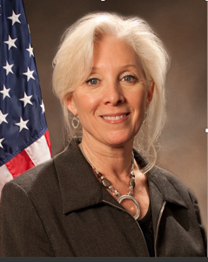
Linda Krieg had a 20-year career serving in the Chicago, Milwaukee and Washington D.C. bureaus of the FBI. In 2010, Ms. Krieg retired from the FBI and joined NCMEC to assume the role of Chief Operating Officer. In this role she oversaw NCMEC’s federal grant, awarded by the U.S. Department of Justice’s Office of Juvenile Justice and Delinquency Prevention. In late 2015, Ms. Krieg retired from NCMEC and moved to the Milwaukee area. She is an elected official serving on the Ozaukee County Board of Supervisors. Ms. Krieg received a Juris Doctor from Hofstra University School of Law and a Bachelor of Business Administration in marketing from Baruch College.

WORKSHOPS:

Audience | Session 1: 9:45-10:15 | Session 2: 10:45-11:15
Couples and Young or New Families | Family Budgeting 15A  Discuss strategies to pay the often-exorbitant bills of child-care a mortgage and find ways to save. | Investing for the Future  Can you look ahead to college for the kids and your own retirement? Yes! Here is how.
Presenter | 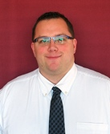  Josh Branham serves as the Branch Manager at the First Bank Financial Centre, Grafton. He got involved in the banking industry 10 years ago to combine his interest in banking with a desire to help people. He hopes to have a positive impact in the lives of my customers, employees, coworkers and my community. | 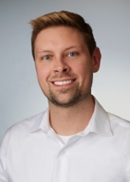  Josh McDonald is the Consumer Lending Manager for Kohler Credit Union. He has held several roles within credit union operations and has been a frequent presenter on financial-related matters.
Planning for Young Adults | Preparing for College 15B  The Office of Student Financial Aid from UW-Madison will share about the FAFSA and financial aid processes as well as share about some of their prominent aid programs like Bucky’s Tuition Promise and FASTrack. | Prepare for Life After High School  This workshop will help students moving into the real world. Topics covered will include budgeting, paying bills, dealing with credit cards.
Presenter | 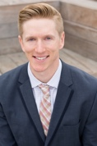  Greg Offerman works on the Advising & Outreach team in the Office of Student Financial Aid for UW Madison where it is their mission to help students navigate the higher education process as well as achieve success once they arrive on campus. | 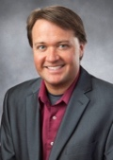  Jamie Schramm is the Community Outreach Manager for Kohler Credit Union. He is a frequent presenter in various community settings on financial and business-related topics.
Planning for Retirement | Estate Planning + Planned Giving 15C  This session will help you prepare your estate by learning about the purpose of a will, how a living trust works and can serve you as well as tax issues and power of attorney. | How to Pay for Long-Term Care 15C  Being prepared for retirement can be stressful. Making sure we will have the appropriate care is of utmost importance. This session will define long-term care and help you know how to navigate the cost of long-term care, Medicare and long-term care insurance.
Presenter | Gerald H. Antoine is an attorney with the law firm of Antoine, Hoeft & Eberhardt, S.C., in Port Washington. The law firm was established in 1948, and Gerry has been with the firm since his graduation from UW Law School in 1977. He is a life-long resident of Ozaukee County. The firm is a general practice firm. Gerry practices primarily in the areas of estate planning, probate, municipal law, collection law, and real estate. | 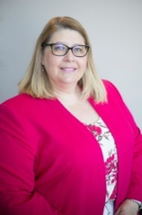  Betty Wellhoefer Hill is the President of Crescendo Wealth Management, LLC which she founded in 2013. After spending almost 19 years at a regional broker dealer, starting Crescendo was the fulfillment of a lifelong dream for Betty. Betty, a CERTIFIED FINANCIAL PLANNER™, and her team provide individuals and families with a full range of Holistic Financial Planning Services including wealth accumulation planning, retirement income planning, investment selection, investment allocation planning, risk management a/k/a insurance planning, taxation and estate planning. Crescendo also provides specialized planning services to families with special needs loved ones, to mid-career women executives and pre to post retirees. Betty is a graduate of the University of Wisconsin—Eau Claire, with a BBA in Finance and an MBA from Marquette University.
For All | Your Credit Report LMC  In this session you will learn the what a credit score is, the importance of credit, how to read a credit report and improve your credit score. | Your Credit Report LMC  In this session you will learn the what a credit score is, the importance of credit, how to read a credit report and improve your credit score.
Presenter | 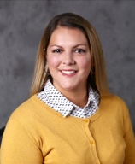  Meghan Menke has been a Personal Banker with Port Washington State Bank for over 7 years. She earned her finance degree from UW Madison and has been in banking for over 14 years. She is passionate about education – specifically Financial Education. | 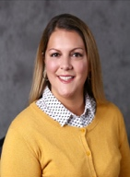  Meghan Menke has been a Personal Banker with Port Washington State Bank for over 7 years. She earned her finance degree from UW Madison and has been in banking for over 14 years. She is passionate about education – specifically Financial Education.

